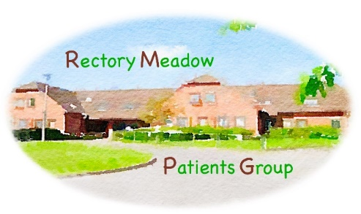

AGENDA

RECTORY MEADOW PATIENTS GROUP
COMMITTEE MEETING

Friday 6 February 2026 @ 11:00
Rectory Meadow Surgery – Ground Floor Meeting Room

Committee:
George Allison (GA) Alexis Johns (AJ)
Tony Burckhardt (TB) Ann Lawrence (AL)
Julie Burton (JB) Peter McLoughlin (PM)
Graham Cook (GC) Debbie Ratu (DR)
Liz Davidson (LD) Drene de Silva (DdS)
Hilary Hamer (HH) Helen Woods (HW)
Lynda Hampson (LH) Mike Wort (MW)
Mike Hender (MH)

 | Item | Action
1. | Apologies for absence  Apologies were received from Tony Burckhardt, Mike Hender and Peter McLoughlin.
2. | Minutes of the last meeting held on 7 November 2025  The minutes were proposed by LH, seconded by AL.
3. | Matters arising  Nil.
4. | Surgery update  - Dr Sena has now left the practice.  - Dr Nunwa joins the practice on 13 April covering Dr Sena’s role, working 3 days per week.

 | Item | Action
4. | Surgery update (continued)  - The CQC inspection at the end of November went well, with a great deal of information provided prior to the inspection. A link to the summary report can be found on the surgery website, with the full report available via the CQC website. The surgery was assessed against 34 indicators, scoring 13 within Outstanding and 21 within Good. In particular, the surgery scored Outstanding in four out of five areas within “Caring” for both staff and patients which is hard to achieve.  - Focus for 2026 is to embed processes and drive efficiencies.  - Roll out of DNACPR forms moving online.  - AJ is reviewing car parking, looking at a company to manage this on the surgery’s behalf. This is to stop non-surgery users from preventing patients parking. There is no financial outlay by the surgery, nor will there be an income from fines.  - The team are currently focussing on end of year.  - New Receptionist Natalie has started and is settling in well.  - The surgery team have become a more cohesive MDT.  - AJ will present an NHS app update at the next General Meeting, with DR presenting on the CQC inspection as well as a general update.  Q.  JB queried a text message received regarding a medication review. DR confirmed those on 8+ medications plus over the age of 75 years have received a text inviting them for a review. This initiative commenced six months ago. | ALL to note
5. | Mid Chiltern Primary Care Network (PCN)  MW reported the most recent PCN meeting was superb, with lots of input coming through.  - Head of Mid-Chiltern section of PCN is now attending meetings regularly and meetings have vastly improved.  - A good team has been formed from all surgeries within the PCN.  - MW will produce an update for patients regarding PCN activities, which will be circulated to members following the General Meeting on 27 February.  - Next surgery newsletter will be circulated in March. JB will provide AJ with RMPG text for inclusion. AJ is managing communications for the surgery. | MW  JB

 | Item | Action
6. | Next patient presentation  Q.  GA queried why communication is so poor. HW reported ongoing issues with circulation to members via email which is actively being addressed following an in-person meeting between MW, HW and DdS. Work is ongoing.  The next patient presentation is confirmed for Monday 20 April at 14:30, to be held at Barn Meadow Community Hall. Entitled “The Gut, from Top to Bottom”, our speaker will be Professor Christine Norton.  MW reported that Lynn Colley, Mid Chiltern PCN Business Manager has agreed that a Gastroenterologist from the PCN can also attend this presentation to add to the discussion in terms of treating certain gut diseases.  Hilary Hamer left the meeting.  GA reported that he has reached out to several potential speakers, with responses awaited. | ALL to note  ALL to note
7. | Committee roles for 2026  MW reported these will be circulated by email shortly. | ALL to note
8. | Any other business  None reported.

A reminder of our 2026 meeting dates
Friday 27 February - General meeting
Friday 8 May - RMPG Committee
Friday 29 May - General meeting
Friday 7 August - RMPG Committee
Friday 21 August - General meeting
Friday 6 November - RMPG Committee
Friday 27 November - General meeting

