

Inside this Issue

Martin Pamington joins the team
Lasting powers of attorney workshop with Chiltern Compass
Pharmacy first hay fever advice.
Latest update direct from our PPG

Afternoon Closures
The Surgery will be closed for Staff Training from 1300:
Thu 18th June 26
Wed 15th July 26
Tues 15th September 26
Thu 15th October 26
Tue 17th November 26
Wed 13th January 27
Thu 11th February 27
Tue 16th March 27

If you need medical advice while the Surgery is closed, please call 111 or 999 if you need urgent care.

Missed
Appointments

Last quarter we had 138
patients who missed their appointments and didn’t inform us.
This is a is a slight decrease on the last quarter, but these missed appointments cost the NHS approximately £6000! It is very important that you let us know if you are unable to attend your appointment so that we may offer it to someone else who
needs it by calling the Surgery on 01296727711 or emailing us at
rectorymeadowsurgery@nhs.net

Rectory Meadow Surgery
Newsletter – Summer 2026
Welcome to our Summer Newsletter!



Latest News

Please welcome Martin Pamington our new Paramedic Practitioner!

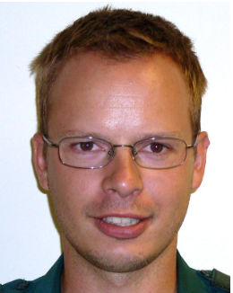
Martin is a highly experienced Paramedic practitioner who has joined the Surgery, Martin is an advanced paramedic practitioner with 25 yrs clinical experience. He has a minor illness diploma, a masters in prescribing and has been within the Primary care setting for 8yrs. He also is a qualified trainer in life support which he provides to clinical and non-clinical staff across the NHS.

On Saturday 20th June you are invited to a workshop on Lasting Powers of Attorney (LPAs) being held at Rectory Meadow Surgery provided by Parveen Haynes, local solicitor, and Dr Lyn Jenkins, retired local GP, Chair of Chiltern Compass.

This informative workshop will:

• Explain what LPAs are and why they are important

• Step-by-step walkthrough of the LPA forms and what to consider when completing it

• safeguards that can be included in the LPAs to protect you and your interests.

The workshop is designed to be practical, easy to understand, and suitable for anyone.

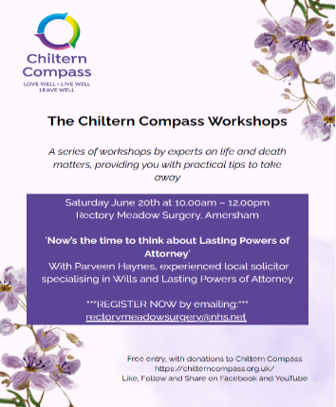

Coping with Extreme Heat

As you age, your body's natural cooling system slows down. This heat sensitivity occurs because your skin circulates less blood to release heat, sweat glands become less active and your body struggles to sense thirst or dehydration.

Follow these essential safety steps when temperatures are forecast to reach the mid-30s °C for an extended period: Protecting older adults:

· Avoid peak sun: Stay indoors between 11am and 3pm.

· Dress appropriately: Wear loose, light-coloured clothing.

· Cool your environment: Close curtains and blinds during the day.

· Ventilate safely: Open windows only at night when the air cools down.

· Use cooling devices: Run fans or air conditioning.

· Lower skin temperature: Use water spray bottles, damp sponges or take cool showers.

· Hydrate proactively: Sip water regularly before you feel thirsty.

· Limit caffeine: Reduce caffeine intake to avoid its diuretic dehydration effects.

Protecting children:

· Shade first: Keep children out of direct sunlight whenever possible.

· Sun protection: Apply high-factor sunscreen (SPF 50+).

· Creative hydration: Offer ice lollies or ice cubes if they struggle to drink enough water.

Join the Rectory Meadow Patients Group (RMPG) Committee!

The Rectory Meadow Patients Group (RMPG) is looking for enthusiastic new members to join our committee.

Over the past two months, we have sadly said goodbye to 4 valued members due to ill health, changing circumstances, and relocation to New Zealand. They will all be sorely missed; however, the responsibilities they managed must continue if we are to maintain our strong support for the surgery – support that directly contributed to the high approval rating in our recent Care Quality Commission (CQC) review.

Why join us?

· Support your surgery: Play a vital role in maintaining high-quality patient care.

· Make a difference: Help shape the services and support available to our community.

What is Health and Wellbeing Coaching?

Health and Wellbeing Coaches support patients by empowering them to become more confident at managing their own health. They provide a safe space for patients to explore the gap between their current reality and where they want to get to. Health and Wellbeing Coaches do not give advice. They use a holistic approach to develop the knowledge, skills and confidence of patients, through increasing motivation and promoting behavioural change.

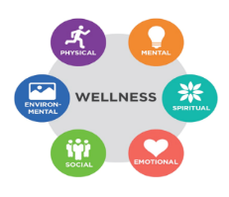
Health and Wellbeing Coaches often focus on areas such as healthy eating, physical activity, weight management, sleep and mental wellbeing. They support the self-management of long-term conditions e.g. hypertension, diabetes, heart disease etc. https://www.midchilternpcn.nhs.uk/health-wellbeing/

