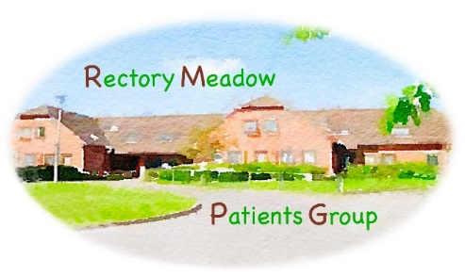

AGENDA

RECTORY MEADOW PATIENTS GROUP
GENERAL MEETING AND AGM

Friday 11 September 2026 @ 14:00
Barn Meadow Community Hall

Committee:
Alexis Johns (AJ)
Julie Burton (JB) Ann Lawrence (AL)
Graham Cook (GC) Peter McLoughlin (PM)
Liz Davidson (LD) Drene de Silva (DdS)
Lynda Hampson (LH) Mike Wort (MW)

AGM

- Apologies for absence
- Approval of minutes 25 August 2025
- Chairmans Report
- Committee Membership

General Meeting

- Approval of the minutes of the meeting held on 29 May 2026

- Matters arising

- Surgery update
- Statutory poll results
- Website walk through – Submitting requests and PPG page
- Sobethan Nathnukumar new ST3 joins the practice for 1 year
- Aby Devereux new practice nurse joins the nursing team

- Primary Care Network (PCN)
Minutes of PCN meetings circulated
- Future events
Drene de Silva to introduce new speaker option. Date and time to be agreed

- Roles and responsibilities

- Any other business

A reminder of our 2026 meeting dates
Friday 11 September - General Meeting
Friday 06 November - Committee Meeting
Friday 27 November - General meeting

